Highlighting Leadership offer: 2016/17
Purpose

For information.

Summary

This report updates members on engagement with the LGA’s Highlighting Political Leadership offer as well as an update on the Be a Councillor campaign and the managerial leadership development opportunities.

Recommendation

That the Improvement and Innovation Board notes the report and offers any comments on the Highlighting Leadership work.

Action

Officers to progress this work in light of the Board’s comments.

Contact officer: | Will Brooks
Position: | Principal Adviser - Leadership and Localism
Phone no: | 0207 664 3053
Email: | william.brooks@local.gov.uk

Highlighting Leadership offer: 2016/17

Background

- The LGA’s Highlighting Leadership offer forms part of our wider package of sector-led improvement. We offer a range of programmes, events and resources aimed at supporting and developing councillors at all levels. Attending our political leadership programmes gives councillors a unique opportunity to network with other Members from different tiered authorities and often across the political spectrum. Our managerial leadership development programme starts by growing future talent with the National Graduate Development Programme, through to opportunities for senior officers with the Institute of Directors.

- This report provides statistics relating to attendance at our leadership development programmes and commentary on the achievements and progress to date.

Highlighting Political Leadership

- The LGA continues to offer a wide range of development opportunities for councillors. Alongside flagship programmes such as Leadership Academy and Next Generation, the LGA offers specialised masterclasses and residential courses on topics such as scrutiny, finance, children’s services and sport. Our catalogue of programmes is regularly reviewed to ensure that it reflects what is relevant within the public sector and meets the needs of councillor attendees. In 2016/17 one new programme has been added, which focusses on a council’s role in tackling extremism.

- Bookings as of 3 January 2017 on the Leadership Academy (LA), Leadership Essentials (LE), Focus on Leadership (FoL), the Leader’s Programme (LEAD), Next Generation (NXG) and ‘Leading Edge’ are set out in the tables which follow.

- The figures represent an 11% decrease compared to bookings in January 2016. The main factor influencing this change is a decrease in the number of places available to book on our programmes. For example, there have been fewer Leadership Academy programmes compared to last year, and a reduction in the number of Planning programmes. The total figure (649) will increase by the end of the financial year, as there are a number of programmes that are still taking bookings and therefore we anticipate that we will be able to meet the target of 700, in the MoU with the Department for Communities & Local Government.

- In 2016/17 to date, we have had particular success in terms of increasing the diversity of councillors who attend our programme. This is detailed in paragraphs 7 and 8.

Political Leadership development programme bookings

By political party:
 | LA | LE | Fol | LEAD | NXG | LEDGE | Total
Labour | 45 | 174 | 37 | 4 | 20 | 3 | 283
Conservative | 31 | 152 | 23 | 4 | 15 | 10 | 235
Liberal Democrat | 9 | 23 | 17 | 1 | 14 | 0 | 64
Independent | 20 | 20 | 12 | 0 | 14 | 1 | 67
Total: | 105 | 369 | 89 | 9 | 63 | 14 | 649

By region:
 | LA | LE | Fol | LEAD | NXG | LEDGE | Total
East of England | 12 | 36 | 12 | 2 | 8 | 8 | 78
East Midlands | 10 | 27 | 7 | 0 | 6 | 1 | 51
Greater London | 9 | 46 | 9 | 1 | 11 | 1 | 77
North East | 3 | 13 | 1 | 1 | 4 | 0 | 22
North West | 6 | 39 | 6 | 2 | 6 | 1 | 60
South West | 14 | 55 | 11 | 0 | 5 | 1 | 86
South East | 15 | 60 | 12 | 2 | 15 | 1 | 105
Wales | 22 | 0 | 1 | 0 | 2 | 0 | 25
West Midlands | 6 | 53 | 18 | 0 | 4 | 1 | 82
Yorkshire & Humber | 8 | 40 | 12 | 1 | 2 | 0 | 63
Total: | 105 | 369 | 89 | 9 | 63 | 14 | 649

By tier:
 | LA | LE | Fol | LEAD | NXG | LEDGE | Total
District | 35 | 113 | 36 | 4 | 24 | 8 | 220
County | 4 | 37 | 4 | 0 | 7 | 2 | 54
Metropolitan | 14 | 73 | 22 | 1 | 10 | 0 | 120
London | 9 | 46 | 9 | 1 | 11 | 0 | 76
Unitary | 21 | 90 | 17 | 3 | 9 | 4 | 144
Welsh | 22 | 0 | 1 | 0 | 2 | 0 | 25
Fire | 0 | 10 | 0 | 0 | 0 | 0 | 10
Parks | 0 | 0 | 0 | 0 | 0 | 0 | 0
Total: | 105 | 369 | 89 | 9 | 63 | 14 | 649

LA = Leadership Academy LE = Leadership Essentials
FoI = Focus on Leadership LEAD = Leaders Programme
NXG = Next Generation LEDGE = Leading Edge

Ethnicity and gender of attendees

- The LGA is committed to ensuring that all of our programmes are accessible and appealing to Councils and councillors across our Member authorities. During 2016/17 to date, 17% of attendees at our political leadership programmes have identified as BAME (Black, Asian, Minority Ethnic). This compares to 10% of attendees in 2015/16, and only 4% of councillors nationally.

- There remains a significant gap in terms of the number of women attending our programmes compared to men (42% to 58%). However, progress has been made in the year to date, with the 2015/16 figures showing a wider gender divide (62% male to 39% female). It should also be noted that on a national level, the LGA Member Census 2013 found that only 32.7% of councillors are female. Increasing diversity amongst the candidate pool is part of the LGA’s flagship Be a Councillor campaign, which is covered later in the report.

Longer-term impact evaluation

- Members will recall that they commissioned an evaluation of the political leadership programmes at a previous meeting. The data collection is now complete and report writing is underway. A survey, based on our Political Skills Framework, was sent to all councillors who have taken part in one or more of our programmes within the last two years (approximately 850 currently-serving and former councillors). Follow up interviews took place with 12 councillors, to help gather more detailed and anecdotal feedback. The survey opened on 26 May, running for 4 weeks, with the aim of understanding the impact our programmes make and how, if at all, participants’ learning has become embedded and behaviours have changed as a result of attending our programmes. Approximately, one fifth of councillors in our sample took part (139 in total). The following word cloud has been created with the data that has been analysed so far. The size of the word reflects the number of times the word was used:

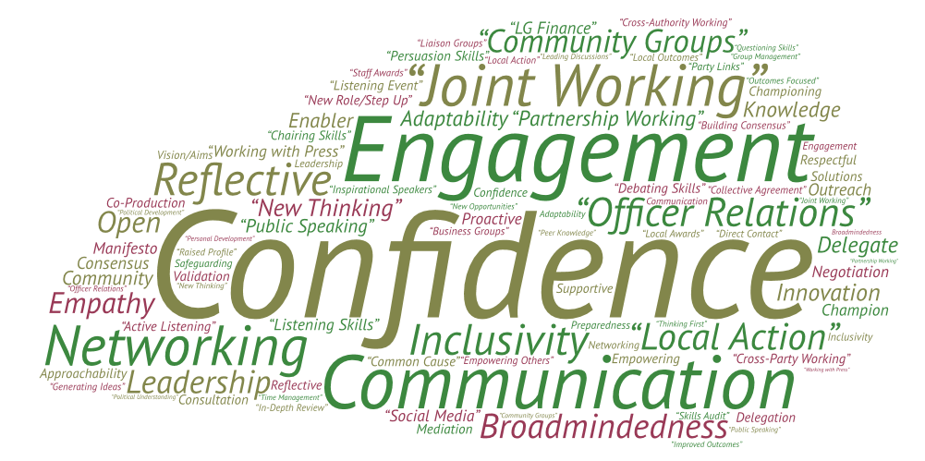

- A summary of initial findings is detailed below:

  - Eight out of ten respondents who took part in our programmes did so to ‘develop their capacity to lead’ and ‘to network and learn from other councillors’.

  - Ninety five percent said their objectives had been ‘fully achieved’ or ‘largely achieved’ by the leadership programme(s) they attended.

  - Ninety six per cent said they felt more confident in their role as a councillor either ‘to a great extent’ or ‘to a moderate extent’, having participated in our leadership programmes.

  - Within the area of local leadership, 91 per cent said their skills in ‘building partnerships with others’ had improved a great or moderate amount due to the training.

  - Regarding partnership working, 91 per cent said their skills in ‘maintaining good relationships with colleagues and contacts’ and ‘supporting and empowering others’ had improved a great or moderate amount due to the training.

  - Within the area of communication skills, 85 per cent said their skills in ‘listening well and adapting to others’ had improved a great or moderate amount due to the training.

  - Regarding political understanding, 88 per cent said their skills in ‘working well with people who hold different views and values’ had improved a great or moderate amount due to the training.

  - Within the area of scrutiny and challenge, 84 per cent said their skills in ‘being fair, objective and rigorous when challenging processes and people’ and ‘presenting arguments that are always concise, meaningful and easily understood’ had improved a great or moderate amount due to the training.

  - Regarding regulating and monitoring, 78 per cent said their skills in ‘seeking feedback or looking for opportunities for personal development’ had improved a great or moderate amount due to the training.

- The findings of this evaluation project will be used to help prepare and plan our programme of development opportunities for councillors for 2017/18 and beyond. A full report will be available at the next meeting.

Be a Councillor

- The LGA’s Highlighting Political Leadership offer provides support and development to councillors throughout their local government political career. We also recognise that prospective councillors will benefit from access to advice, information and guidance before making a decision about whether or not to stand. The Be a Councillor campaign focusses on raising the profile of the role of a councillor, with the aim that more people will choose to stand as a candidate.

- During 2016/17, the Be a Councillor campaign has been transformed to ensure that it remains relevant and meaningful in a digital age. A new Twitter handle (@beacouncillor) has been launched, which has generated up to 50,000 impressions (people who saw or hovered over a tweet) in any given month. The LGA also highlighted the Be a Councillor campaign during European Local Democracy Week, which profiled 4 councillors from across the political spectrum and generated over 20,000 tweet impressions during that week, as well as including an article in First Magazine. A short film is currently being produced as part of the series of Sector Led Improvement podcasts.

- The LGA political groups continue to provide their own bespoke Be a Councillor campaigns and have run successful events, produced guidance and provided training to prospective councillors. A pilot project has been undertaken, to trial providing tailored cross-party support to councils to help them undertake their duty to enhance democratic engagement. Following the pilot, a package of resources has been developed and made available to councils, so that they can have any or all of the Be a Councillor products, bespoke to the demographic of their region. Resources include guidebooks, work books, video, website, e-learning module, eligibility quiz and events.

- Throughout 2016/17 the profile of the Be a Councillor campaign has been raised after featuring at a number of public sector events including the London Councils summit, NALC Conference and LGA Conference. Rotherham, Lancashire and East Sussex Councils all have their own bespoke Be a Councillor website, and projects are currently underway with Birmingham and West Sussex. This year has also seen the first Be a Councillor event held in partnership with a council (Isle of Wight), focussed specifically on engaging more women in politics. Work planned for 2017/18 includes developing resources to help promote the role of the councillor to underrepresented groups in politics including women, BAME and young people.

Online resources

- E-learning now has over 8,000 Members and the number of training options available continues to grow. In the last year new modules have been introduced on Influencing Skills, Planning and “What it’s like to be a Councillor”, as part of the Be a Councillor campaign. To ensure that our online resources reflect the ongoing changes in local government they are regularly reviewed, and recent revisions have been made to the Leadership & Engagement Workbook to take account of devolution and its effects on councils and communities.

Highlighting Managerial Leadership

- Following a successful pilot programme for officers during 2016, the LGA is running a further 2 programmes of a commercial skills programme for senior officers in 2017 in partnership with the Institute of Directors. The 8 day programme addresses the need for senior officers to understand the challenges resulting from the increasing commercialisation of council services and the development of local authority trading companies and joint ventures. The programme will include modules on the fiduciary responsibilities of being a board member and need for commercial strategic and leadership skills. This will be supplemented by a series of 1 day workshops for councillors to develop similar skills and competencies but from the perspective of a councillor with a position on a board of a company in their elected role. The first of these will be delivered in the spring of 2017.

National Graduate Development Programme (NGDP)

- NGDP has continued to grow in popularity and success over the past few years, with more councils taking part in the scheme and an increase in application numbers. In response to feedback from councils, the scheme has become more flexible to allow for recruitment from the local area and current graduates employed by a council. Work has also been undertaken to investigate secondment opportunities across different sectors, for example with the Civil Service fast track scheme.

- As of 6 January 2017, the recruitment process for Cohort 19 is in its infancy, with candidates submitting their initial application forms in the first part of the month. There are currently 18 councils (including the LGA) signed up to offer 51 places to graduates as part of the scheme. The deadline for councils is 31 March 2017, and therefore we anticipate that this number will increase.

- Cohort 18 graduates have now started with their councils and there are a total of 95 graduates working across 51 councils (including the LGA).

- Cohort 16 have now reached the end of their time on NGDP and a number have already successfully obtained permanent placements either in their host council or another local authority. The following table shows the known career path of graduates who participated in NGDP cohort 16:

Role after NGDP | number
Local Government | 62 (49 have remained at their host council)
Unknown | 26
other public sector, such as NHS, Housing association’s | 8
other- study, other grad schemes | 6
Private sector | 4
Total | 106

Member Development Charter

- The Member Development Charter and Charter Plus which councils use as a guide and a benchmark for their elected members’ development journey has been refreshed. This Member Development Charter and Charter Plus supports the continuing professional development for councillors by being a contract between the council and its councillors that commits to invest in councillors’ growth and development. The new Charter and Charter Plus can be found here.

Implications for Wales

- There are no specific implications for Wales. The MoU with DCLG covers grant to support improvement in English local government.

Financial implications

- None.

Next steps

- As the new financial year approaches, the Leadership & Localism Team will be reviewing the feedback from the evaluation research and delegate feedback from events. This information will be used to inform the programme of events for 2017/18. Members are invited to suggest any topics for the forward work programme of development opportunities for councillors and senior officers and offer any comments on this report.

